Online Resource 3
Supplemental figures including trait data variability and multivariate analyses in support of McKown et al. “Trait convergence and diversification arising from a complex evolutionary history in Hawaiian species of Scaevola”.

Figure S1. Multivariate analysis of site biotic and abiotic environmental variables for Hawaiian Scaevola species.

Figure S2. Boxplots illustrating variability and interquartile distributions of all functional traits measured in Scaevola species.

Figure S3. Multivariate analysis of trait variables for Hawaiian Scaevola species (Trait-PC1 & 2).

Figure S4. Multivariate analysis of trait variables for Hawaiian Scaevola species (Trait-PC1 & 3).

Figure S5. Multivariate analysis of trait variables for Hawaiian Scaevola species (Trait-PC2 & 3).

Figure S6. Multivariate analysis of wood anatomy for Hawaiian Scaevola species (data from Carlquist, 1969).

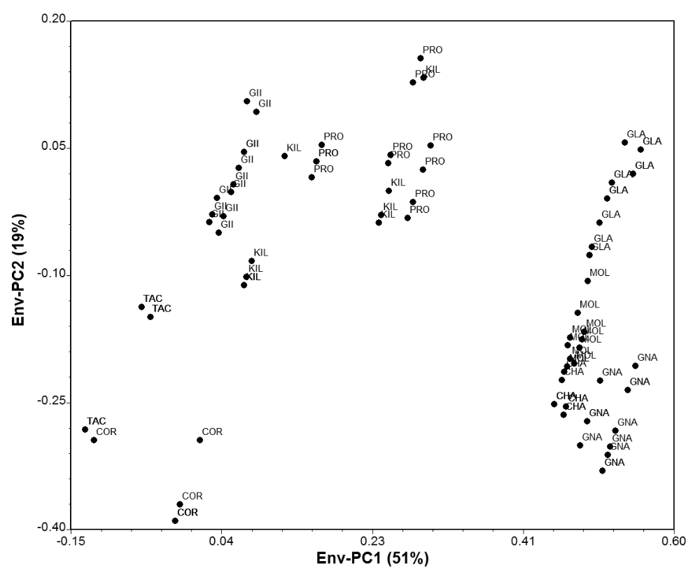
Figure S1. Multivariate analysis of site biotic and abiotic environmental variables for Hawaiian Scaevola species. Environmental principal components (Env-PC) illustrate the two-dimensional spread of all individuals. See Online Resource 2 Table S2 for individual component loadings. Species abbreviations: CHA = S. chamissoniana, COR = S. coriacea, GII = S. gaudichaudii, GLA = S. glabra, GNA = S. gaudichaudiana, KIL = S. kilaueae, MOL = S. mollis, PRO = S. procera, TAC = S. taccada.

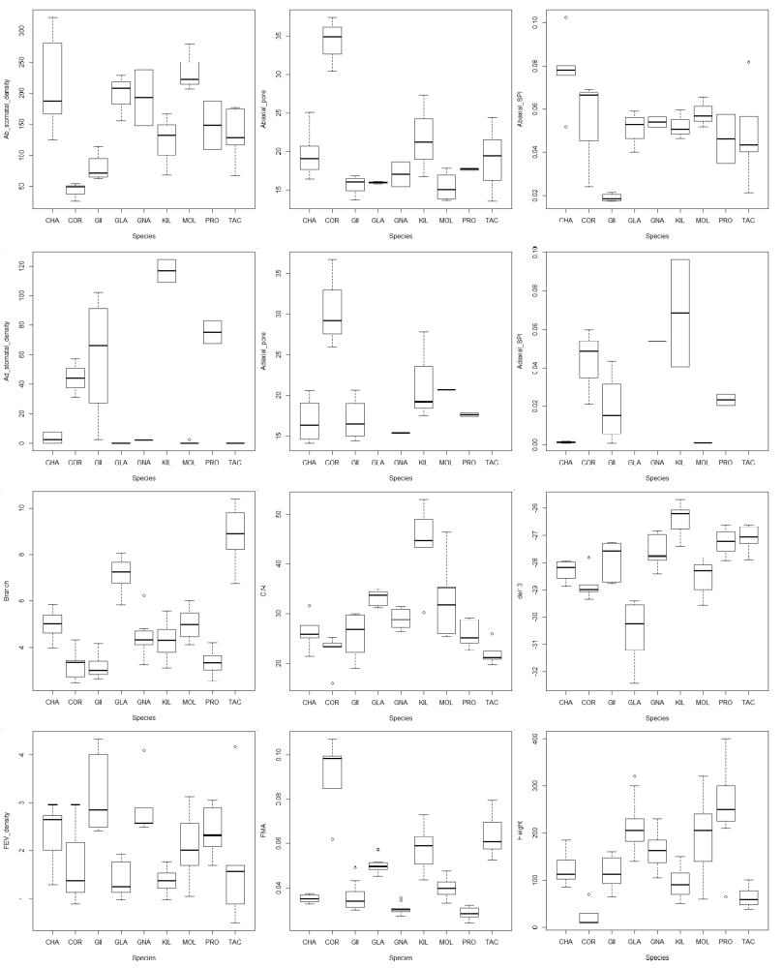
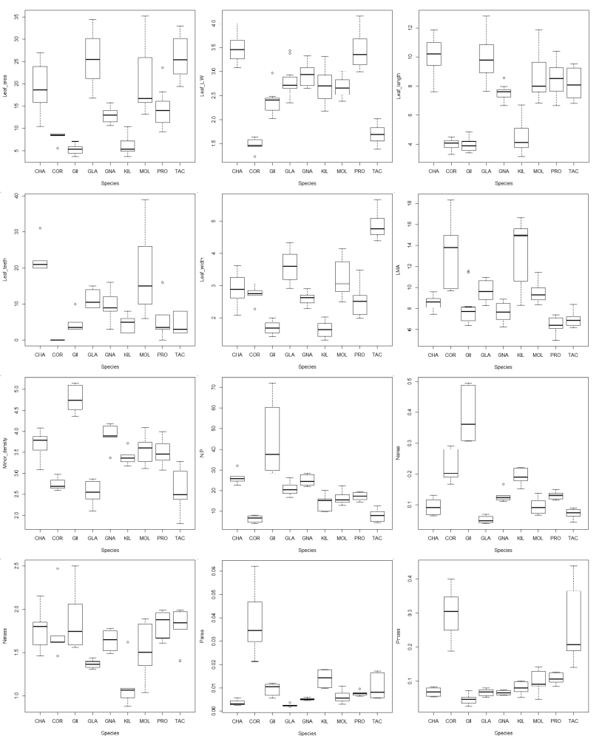
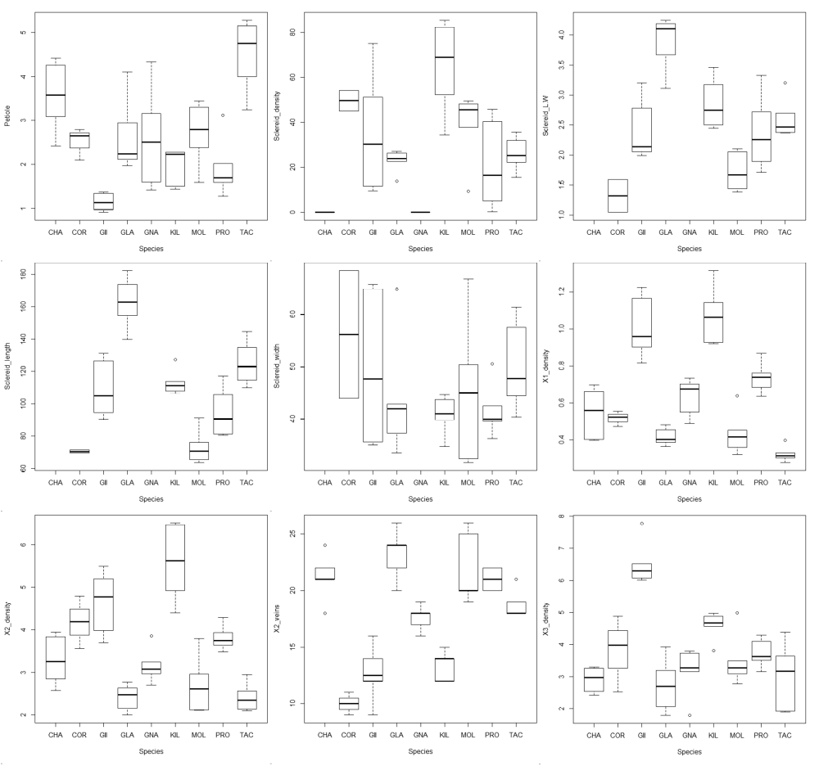
Figure S2. Boxplots illustrating variability and interquartile distributions of all functional traits measured in Scaevola species. See Online Resource 2 Table S4 for trait values, units and description and Table S5 for ANOVA results comparing traits across species. Species abbreviations: CHA = S. chamissoniana, COR = S. coriacea, GII = S. gaudichaudii, GLA = S. glabra, GNA = S. gaudichaudiana, KIL = S. kilaueae, MOL = S. mollis, PRO = S. procera, TAC = S. taccada.

Figure S3. Multivariate analysis of trait variables for Hawaiian Scaevola species (Trait-PC1 & 2). Trait principal components (Trait-PC) illustrate the two-dimensional spread of all individuals on the first and second axes. See Online Resource 2 Table S6 for individual component loadings. Species abbreviations: CHA = S. chamissoniana, COR = S. coriacea, GII = S. gaudichaudii, GLA = S. glabra, GNA = S. gaudichaudiana, KIL = S. kilaueae, MOL = S. mollis, PRO = S. procera, TAC = S. taccada.

Figure S4. Multivariate analysis of trait variables for Hawaiian Scaevola species (Trait-PC1 & 3). Trait principal components (Trait-PC) illustrate the two-dimensional spread of all individuals on the first and third axes. See Online Resource 2 Table S6 for individual component loadings. Species abbreviations: CHA = S. chamissoniana, COR = S. coriacea, GII = S. gaudichaudii, GLA = S. glabra, GNA = S. gaudichaudiana, KIL = S. kilaueae, MOL = S. mollis, PRO = S. procera, TAC = S. taccada.

Figure S5. Multivariate analysis of trait variables for Hawaiian Scaevola species (Trait -PC2 & 3). Trait principal components (Trait-PC) illustrate the two-dimensional spread of all individuals on the second and third axes. See Online Resource 2 Table S6 for individual component loadings. Species abbreviations: CHA = S. chamissoniana, COR = S. coriacea, GII = S. gaudichaudii, GLA = S. glabra, GNA = S. gaudichaudiana, KIL = S. kilaueae, MOL = S. mollis, PRO = S. procera, TAC = S. taccada.

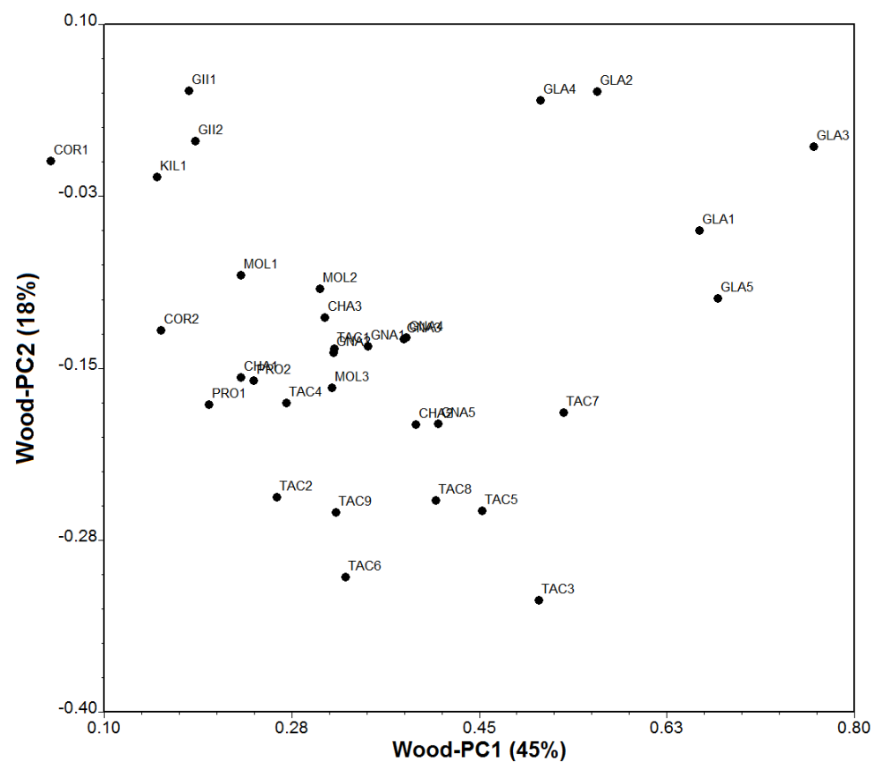
Figure S6. Multivariate analysis of wood anatomy for Hawaiian Scaevola species (data from Carlquist, 1969). Mean values for species along wood trait principal components (Wood-PC) comprising 63% of data variance illustrate distribution of Hawaiian Scaevola. See Online Resource 2 Table S8 for individual component loadings. Species abbreviations: CHA = S. chamissoniana, COR = S. coriacea, GII = S. gaudichaudii, GLA = S. glabra, GNA = S. gaudichaudiana, KIL = S. kilaueae, MOL = S. mollis, PRO = S. procera, TAC = S. taccada.

